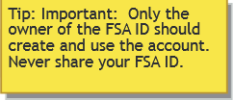
How to create an

FSA ID
The FSA ID -- username and password -- has replaced the Federal Student Aid PIN and must be used to log in to certain U.S. Department of Education websites. Your FSA ID confirms your identity when you access your financial aid information and electronically sign Federal Student Aid documents. If you do not already have an FSA ID, you can create one when logging in to fafsa.gov, the National Loan Data System (NSLDS®) at www.nslds.ed.gov, StudentLoans.gov, StudentAid.gov, and Agreement to Serve (ATS) at www.teach-ats.ed.gov.
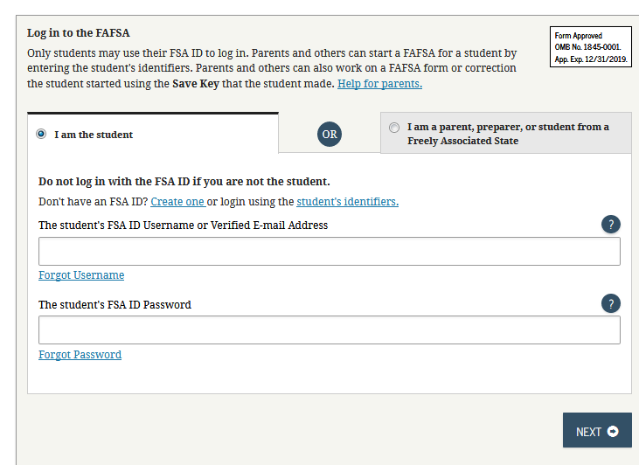
Step 1 When logging in to one of the websites
listed above, click the link to create
an FSA ID.

Step 2 Create a username and password, and
enter your e-mail address.

Step 3 Enter your name, date of birth, Social
Security number, contact information,
and challenge questions and answers.

Step 4 If you have a Federal Student Aid PIN, you will be able to enter it and link it to your FSA ID. You can still create an FSA ID of you have forgotten or do not have a PIN.
Step 5 Review your information, and read and accept the terms and conditions.

Step 6 Confirm your e-mail address using the secure code, which will be sent to the e-mail address you entered when you created your FSA ID. Once you verify your e-mail address, you can use it instead of your username to log into the websites.

You can use your FSA ID to sign a FAFSA right away. Once the Social Security Administration verifies your information in one to three days, or if you have linked your PIN to your FSA ID, you will be able to use your FSA ID to access the websites listed above. For help, visit StudentAid.gov/fsaid.

