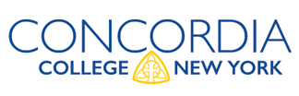
Entrance Counseling and Master Promissory Note Instructions

PLEASE NOTE:
- Students borrowing under the Federal Direct Student Loan Program for the first time; are required to complete BOTH Entrance Counseling and a Master Promissory Note (MPN).
- Students can borrow on a single MPN for up to 10 years so this process will not need to be repeated in subsequent years of enrollment as an undergraduate at Concordia College.
- Entrance counseling is required, as the name implies, at entrance to the loan program and does not need to be repeated in subsequent years.
- Funding will not be disbursed to your Concordia student account until all steps are complete.

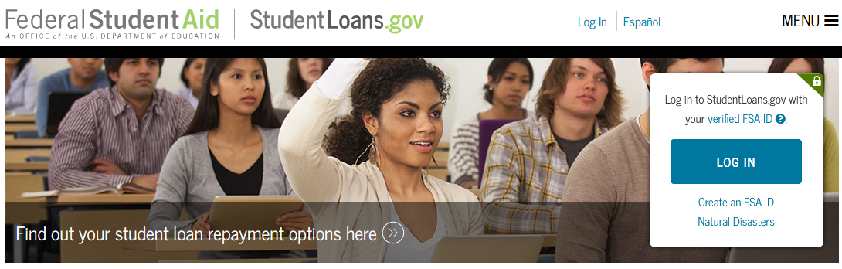
STEP 1: Sign In
Open your browser to www.studentloans.gov and click
Log In. You will need to enter your:
- FSA ID username and password

Step 1

STEP 2: Entrance Counseling
- Click on Complete Counseling
- Click on Entrance Counseling
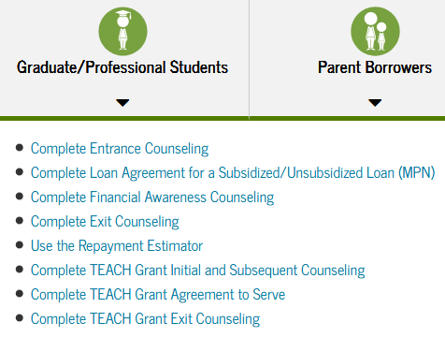
- Insert School Information
- Select Student Type
- Complete Steps 1-5: Counseling Session/Quiz
Step 2

Step 3
STEP 3: Master Promissory Note
- Click on Complete Master Promissory Note
- For Direct Parent PLUS or Graduate PLUS loan, select if applicable.
- Select Complete Subsidized/Unsubsidized MPN
- Complete Steps 1-4: Personal Information, References,
Terms & Conditions, Review & Sign

Please allow approximately 48 hours for Concordia-NY to process your electronic signature. The Financial Aid Office does not have access to www.studentloans.gov. Therefore, if you need assistance in completing the loan application process, please contact Application Services for Federal Direct Loans at (800) 557-7394.

